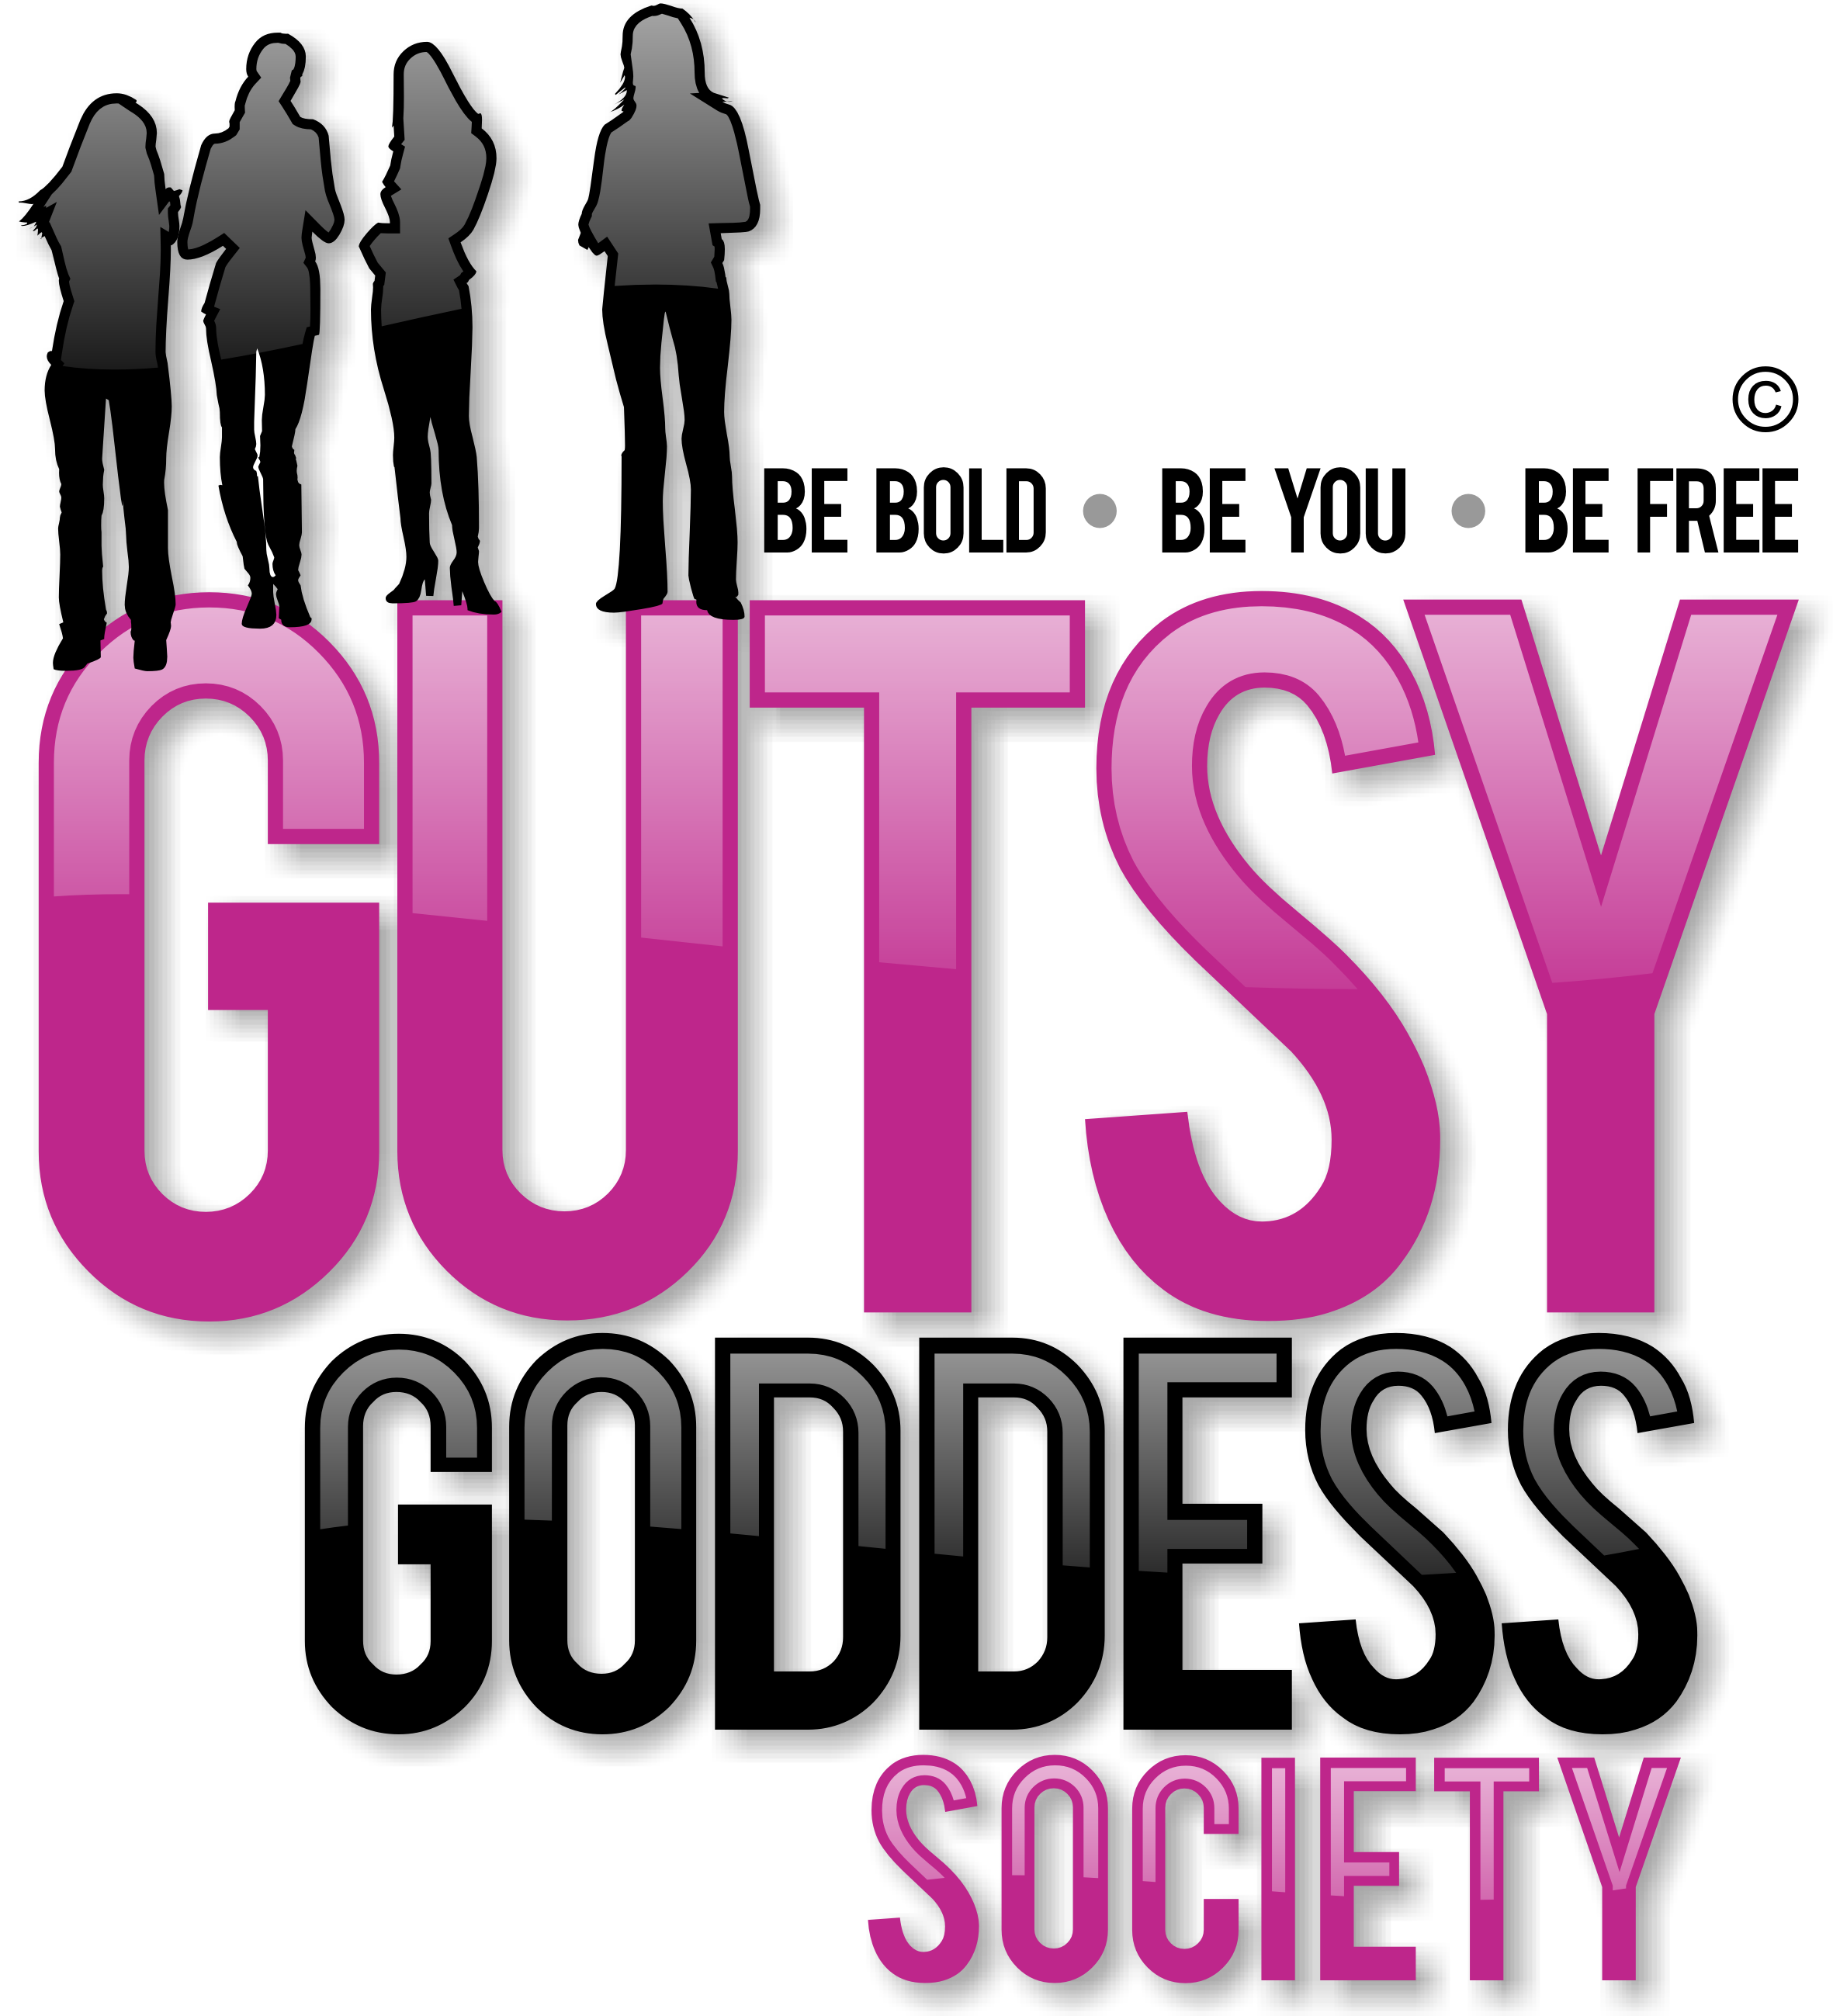

Month 3, Week #4
Share to win: Call for entries

Hi!
I'm looking for some guest bloggers who'd like to share your story of how YOU create traditions and rituals for yourself and/or your family during the holidays and start of the new year ... and if you're doing things any differently this year than in the past due to your journey with the Gutsy Goddess Society.
If you're interested in sharing your story and tips for our community of 2,000+ readers, send it to me here with the subject line - GUEST BLOG.
This is great visibility for YOU and an awesome way you can practice sharing your voice and spreading a powerful message. We will publish as many as we can this month. Would love to feature you!
PLUS ... this is how YOU will be considered to be in the running to win the Gutsy Goddess of the Cycle award. This award goes to the gal who is full-on living life with the tools you're learning in the program. Do NOT worry if you haven't listened to every call or done every assignment. The fact that you stepped forward to be part of this program and said YES to you and yes to your dreams speaks volumes. Brag about your growth and fabulousness. Share your excitement about the year ahead! The world needs your voice.
Winner receives a complimentary private Clarity Power Hour coaching session (valued at $297) with me in 2012.
Your article will also be posted on the GGS forum. Fun!
Include:
Title for your article
Your name and title as you'd like it listed
Your photo
Go to www.zenjenny.com to see recent blog posts to get an idea of length and style of blog posts we typically publish. We will edit for readability and style.
Entries and posts are due by THIS Friday, December 30. GOOD LUCK and GO FOR IT. I dare you :)

xoxo
Jenny

