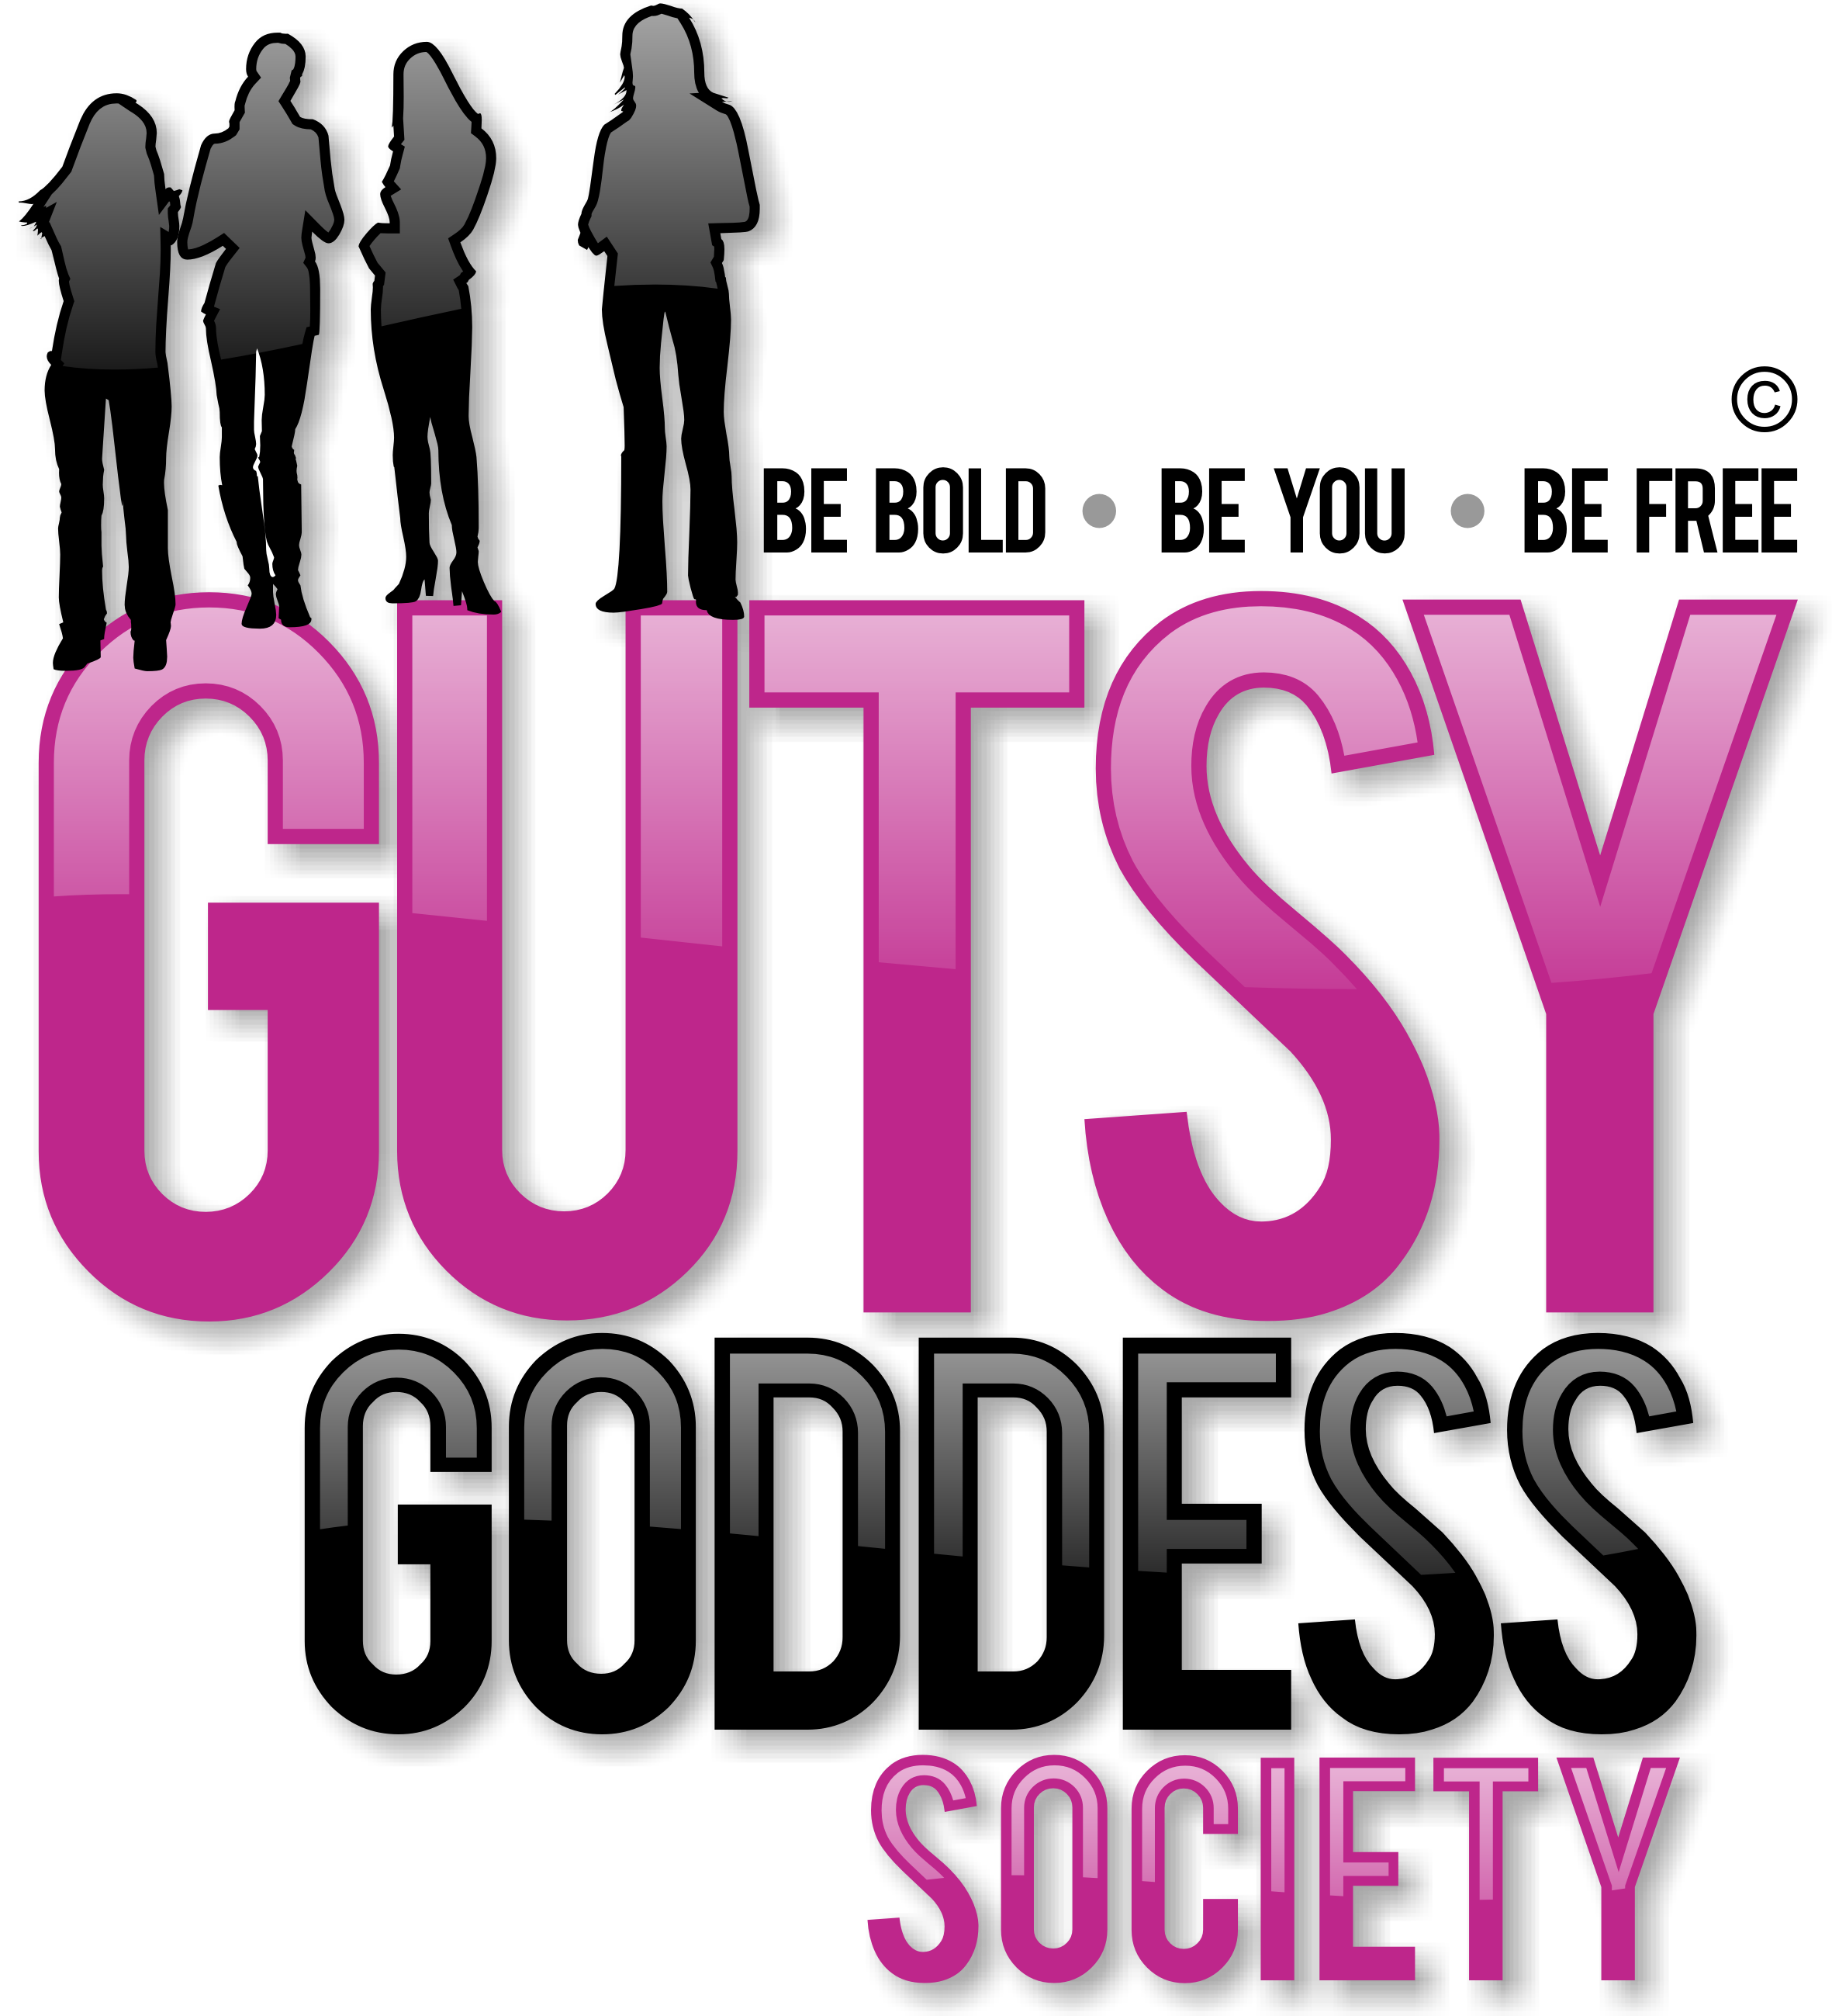

Month 6, Week #1
My fave chakra of them all
Hi!
Whoa! Welcome to Month 6 of our Gutsy Goddess Society training program. I'm beyond thrilled to introduce you to my fave chakra of them all: the 5th chakra, the expression level of your happiness, which is located at your throat. When you're balanced here, others rely on you to speak your truth, and you do. You have put together your own unique worldview, and act on it without needing to prove yourself to others. You have learned how to quiet your thinking mind so that you may listen to the subtle, yet powerful guidance of your wise intuition. Think: Truth. Originality. Innovation. Creative expression.
You know you're imbalanced here if you show inappropriate expression of self - either too little or not enough ... disruptive tendencies ... anxiety.
Our training call is next Monday, March 12. Psyched.
Okay, onto the weekly assignment ...
******************
INSPIRATION IN ACTION ASSIGNMENT
The 5th chakra - "Vishuddha" in Sanskrit - was THE chakra that woke me up when I was in my slumber back in 2007. During my yoga teacher training I created my entire yoga class for my final exam around good ol' chakra #5. Ya, I was in love with it. I had just quit my stressful, high-paying corporate job, was free as a bird and kinda scared out of my mind as I had no plan and no income, but was full of faith that somehow, somehow, everything was going to be a-okay.
All that year I had a poem on my bulletin board in my office in my apartment, which looking back now was essentially my vision board. The poem was sent to me on a Christmas card from my aunt and uncle a year prior. When I read it for the first time, the words literally LEVITATED off the page. They were speaking to me, speaking to my soul, my heart, my voice, begging me to LISTEN.
Here's what that poem said:
Tread in solitude your pathway; Quiet heart and undismayed. You will know things strange, mysterious,` Which to you no voice has said.
While the crowd of petty hustlers Grasps at vain and meager things, You will see a great world rising Where soft sacred music rings.
Leave the dusty road to others, Spotless keep your soul and bright, As the radiant ocean’s surface When the sun is taking flight.
From the German of V. Schoffel Streams in the Desert™ by L. B. Cowman
This poem changed my life. I still have it hanging up and look at it daily. It was sent to me from above!
Your assignment this week ...
=============
ACTION STEPS:
1. Breathe into your throat and massage that area with your hand. Bring energy to this chakra.
2. Ask yourself what TRUTH means to you.
3. Spend some time journaling about truth, painting what you feel, talking to a friend about this idea, you name it. Just dance with this concept and see what comes up for you. This work will shift so much for you, guaranteed.
=============
Dr. Seuss says it so well: “Be who you are and say what you feel because those who mind don't matter and those who matter don't mind.
Share your experiences on our GGS forum and/or our private Facebook page. Speak up.
xoxo
Jenny
P.S. TODAY is the LAST day you can hop into the Live Your Dream Challenge, an 8-week group coaching + training adventure that's the PERFECT complement to our work in the Gutsy Goddess Society training program. If you're ready to dream BIG and make it happen this year, join us at a steal of a price for a GGS gal like you. $57! (The program retails for $177.) Wowzers. Use the coupon code - GGSDREAMER - to score your deal by midnight tonight if you feel called. This is some GOOD stuff, darcee! So many amazing, dreamy gals already in the group. Wanna join us?
http://theliveyourdreamchallenge.com

