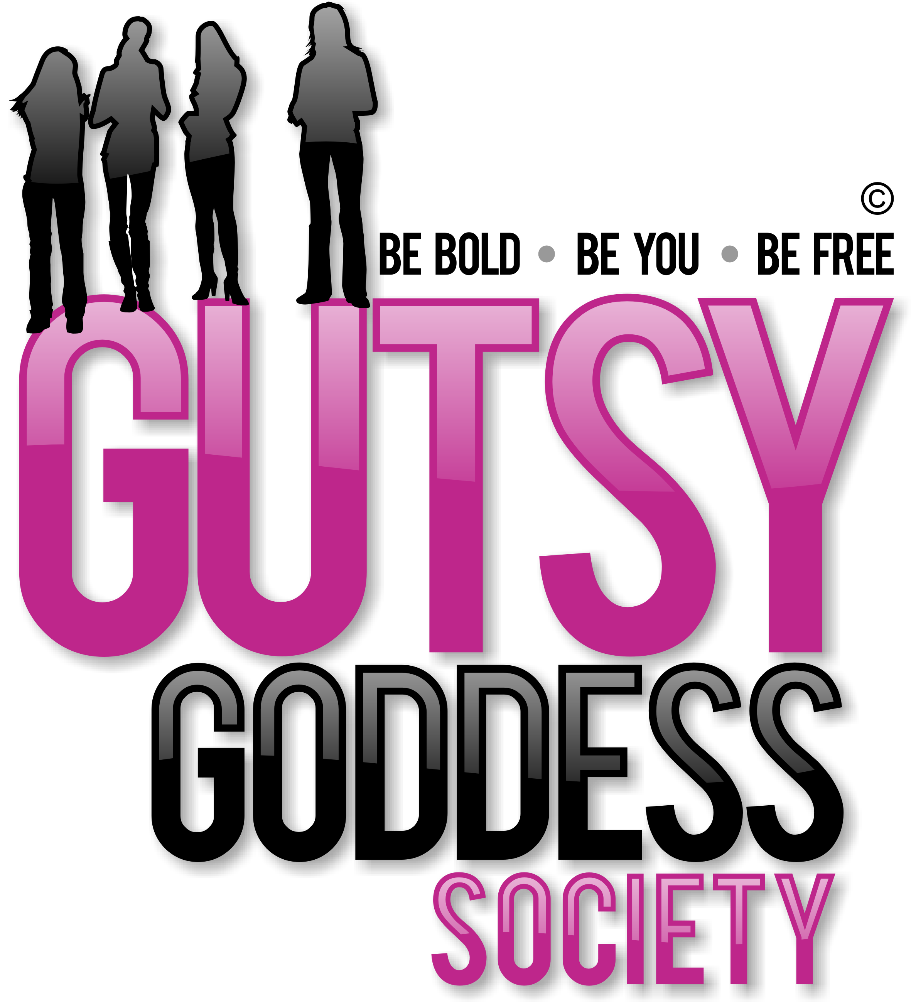

Month 7, Week #1
Igniting Insight, Wisdom + Intuition
Hi!
Holy moly! Welcome to Month 7 of our Gutsy Goddess Society training program - Igniting Insight, Wisdom + Intuition.
This month we're gonna dive into chakra #6, the mental level of your happiness, which is located at the third eye, between your eyebrows at the bridge of the nose. Here's an overview of chakra #6, which we will really get to know next week during our GGS training call. Can't wait!
Color: Indigo blue Signs you are OUT of balance here: Undisciplined mind. Escapism. Illusion. Ungrounded vision. Excessive daydreaming. Worry. Fear.
Signs you are IN balance here: "The mind is a wonderful servant but a terrible master." This saying describes your talent for gaining the best of the mental level without becoming a slave to it. You are able to rise ABOVE the noise of the everyday world to a place of inner refuge and calm where your beautiful imagination leads you to unlimited sources of inspiration. You have learned to hang out in your Observer state (we'll cover this on our training call) and often experience the bliss of pure observing. Your sensitivities to subtle vibrations allow you to connect with light, sound and all of nature as sources of energy.
The goal: see what you see WITHOUT judgment. Not easy, but so worth it.
Okay, onto the weekly assignment ...
******************
INSPIRATION IN ACTION ASSIGNMENT
Bring your pointer finger to your third eye and rub that area to activate it. This is your 6th chakra.
You could put some scented oils or balm there to bring in a more sensorial experience. I recently picked up some Badger Yoga + Meditation Balm with a cedarwood + mandarin scent. LOVE it. I just rubbed some on my 6th chakra and already feel more awake and in tune. Try it.
******************
By learning to skillfully navigate and play in the MENTAL realm, you have enriched your possibilities for happiness many times over. How cool is that?!

