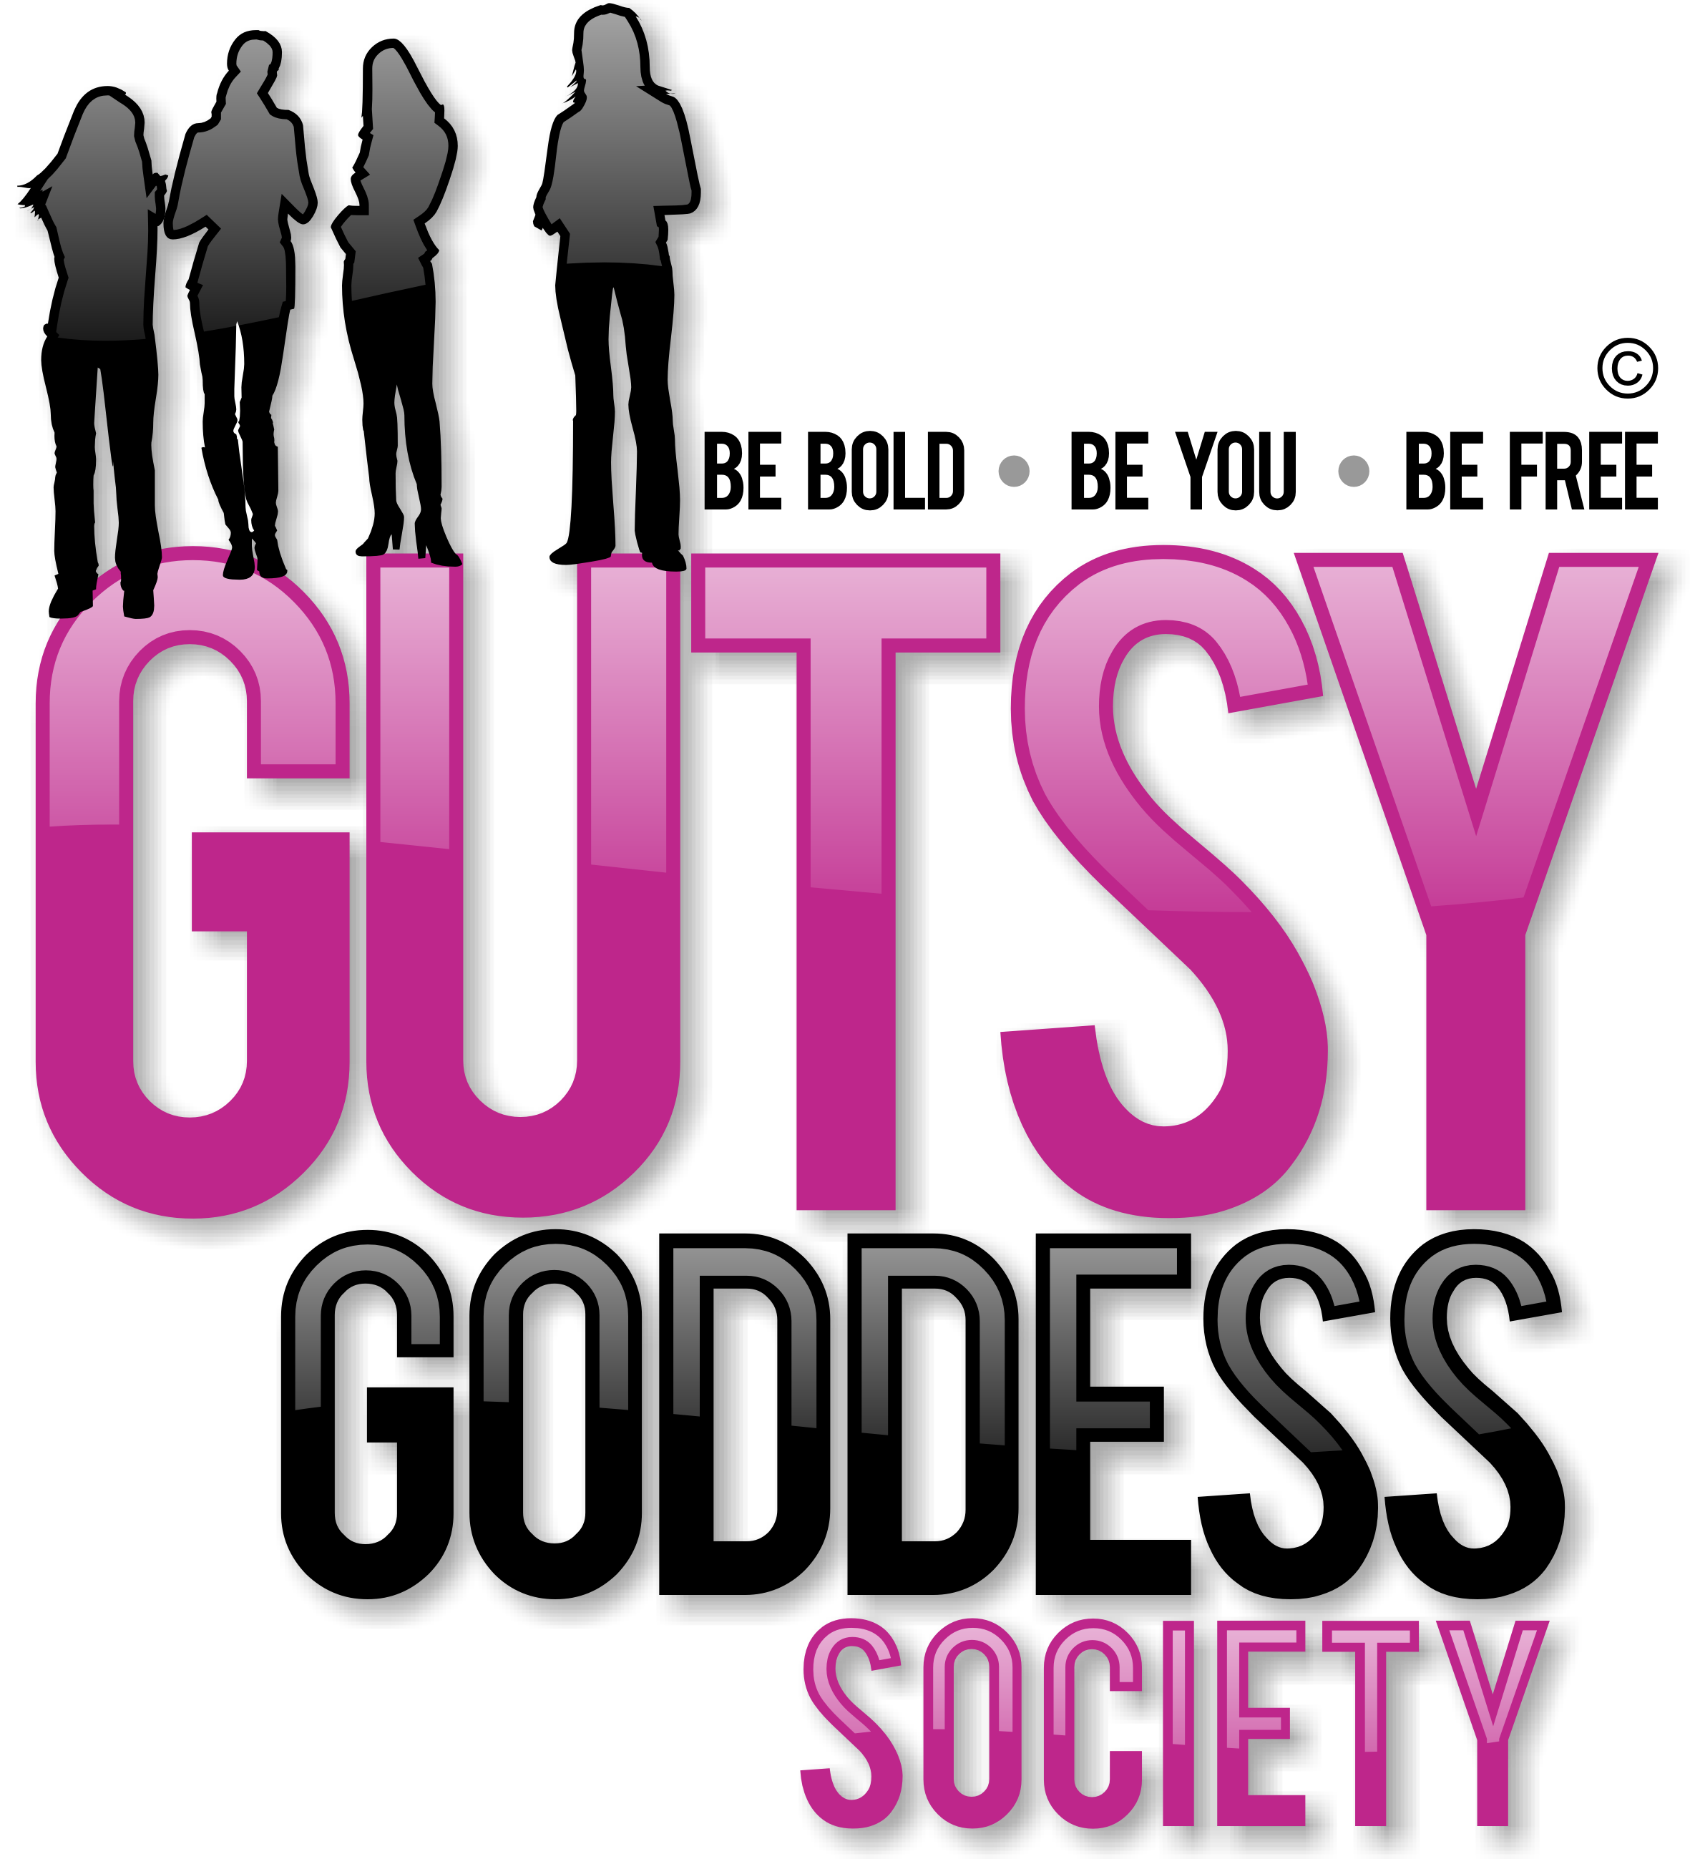

Month 8, Week #1
Love the silence

Wow. Welcome to Month 8 of our Gutsy Goddess Society training program - Charting Your Course.
This month we're gonna dive into chakra #7, the spiritual level of your happiness, which is located at the crown of your head. Here's an overview of chakra #7, which we will really get to know next week during our GGS training call. Can't wait!
Color: Violet Signs you are OUT of balance here: Inability to connect with reality. Disassociation.
Signs you are IN balance here: You have become a universal being, not by sacrificing the self, but by liberating yourself from attachments to other levels and anchoring yourself within the Divine. You become absorbed in this state. You are integrated at all levels. The cool part here? You can participate in all of life smoothly, without being ruffled by the highs and lows that tug on your sleeve.
You accept as sacred grace all that life places before you.
Okay, onto the weekly assignment ...
******************
INSPIRATION IN ACTION ASSIGNMENT
Appreciate the value of SILENCE.
Silence is one of the direct paths to experience the spiritual level. With silence, you can listen to what's happening inside. You can absorb. There is a saying that brings this to life: "Silence is the true language of God; all others are poor translations."
Have a meal in silence this week. Don't read. Don't write. Don't talk. Just sit and observe. Experience the silence.
******************
We've moved up all the chakras together. This is the pinnacle. Let's enjoy this ride to the fullest. You've earned it.
xoxo
Jenny
P.S. Have you seen the NEWS? Registration for the Retreat for Goddesses is full speed ahead! Only 7 spots remain. I'd LOVE to see you there for a transformative weekend that will bring your Gutsy Goddess Society journey to an exciting head. Check out the magic here. http://retreatforgoddesses.com

