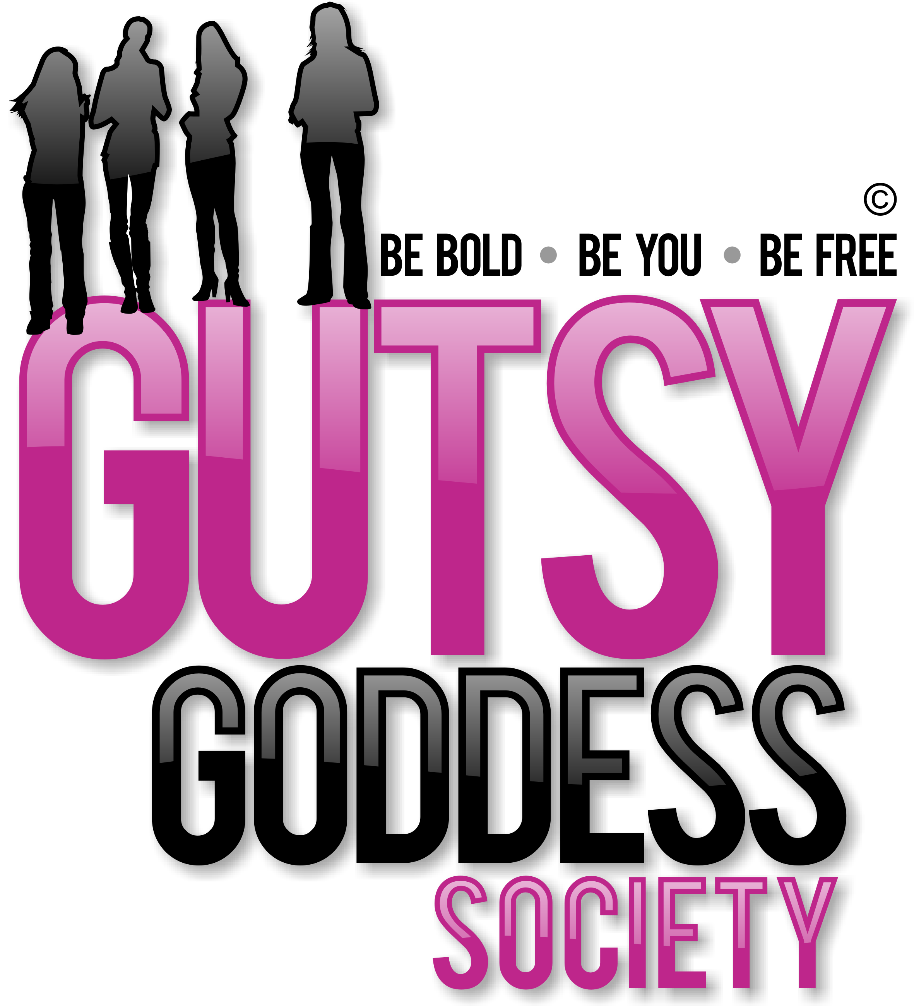

Month 8, Week #3
Playing your instrument well

Wow. Welcome to Month 8 of our Gutsy Goddess Society training program - Charting Your Course.
This month we're diving into chakra #7, the spiritual level of your happiness, which is located at the crown of your head. Here's an overview of chakra #7.
Color: Violet Signs you are OUT of balance here: Inability to connect with reality. Disassociation.
Signs you are IN balance here: You have become a universal being, not by sacrificing the self, but by liberating yourself from attachments to other levels and anchoring yourself within the Divine. You become absorbed in this state. You are integrated at all levels. The cool part here? You can participate in all of life smoothly, without being ruffled by the highs and lows that tug on your sleeve.
You accept as sacred grace all that life places before you.
We covered this in depth on our monthly training call. It was special and deep. If you missed it, check it out here: http://jennyfenig.com/ggs-success-library-woo-hoo/
Okay, onto the weekly assignment ...
******************
INSPIRATION IN ACTION ASSIGNMENT
Just as a clear light holds all the colors of the rainbow within it, at the spiritual level you embrace all of life before you. Your heart, mind, spirit, emotions, body (everything!), and all the other levels become an instrument that the spiritual level expresses through.
This is YOUR INSTRUMENT.
It's up to you to play it and to play it well.
Play your song, play your music.
Go ahead. Have some fun with this right now, darcee :)
******************
We've moved up all the chakras together. This is the pinnacle. Let's enjoy this ride to the fullest. You've earned it. You're a survivor and a thriver ...
xoxo
Jenny
P.S. Have you seen the NEWS? Registration for the Retreat for Goddesses is full speed ahead! Only 6 spots remain. I'd LOVE to see you there for a transformative weekend that will bring your Gutsy Goddess Society journey to an exciting head. Check out the magic here. http://retreatforgoddesses.com

