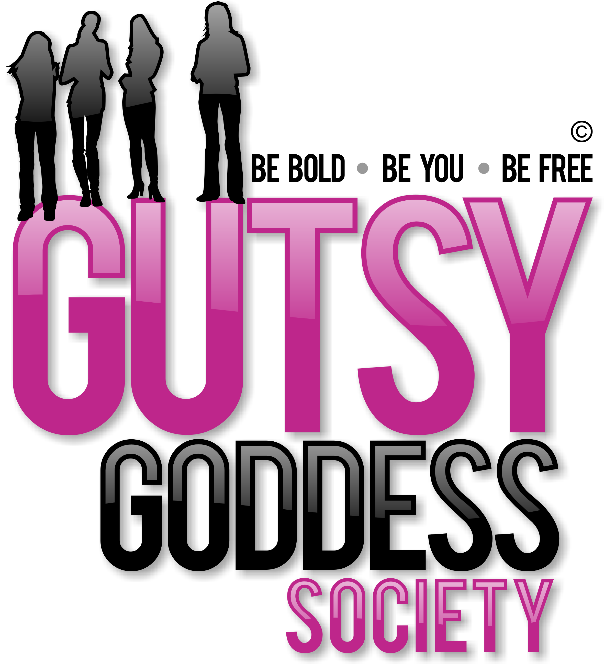

Month 9, Week #1
Be playful as a pussycat
Wow. Welcome to Month 9 (our last!) of our Gutsy Goddess Society training program - Enjoying the Ride (Having More Fun!).
This month we're going to bring all the puzzle pieces together and conclude our program with a BANG! This is our 9th and final month together. What an adventure. This call is all about ensuring you are ENJOYING yourself and all the yumminess that life has to offer. If not, what's the point? Too many women fall short here. Let's pave the way for a female revolution where fun is the focus.
We covered this in depth on our monthly training call. It was profound. If you missed it, check it out here: http://jennyfenig.com/ggs-success-library-woo-hoo/
Okay, onto the weekly assignment ...
******************
INSPIRATION IN ACTION ASSIGNMENT
Listen to the training call and learn more about our Goddess of the Month, BAST. Her message: be playful as a pussycat. She's the perfect gal to bring this message home.
The affirmation you'll say all month:
"I love to play!"
******************
We've moved up all the chakras together. This is the pinnacle. Let's enjoy this ride to the fullest. You've earned it. You're a survivor and a thriver ...
xoxo
Jenny
P.S. Have you seen the NEWS? 1 spot left at the Retreat for Goddesses. Check out the transformational experience here. http://retreatforgoddesses.com

