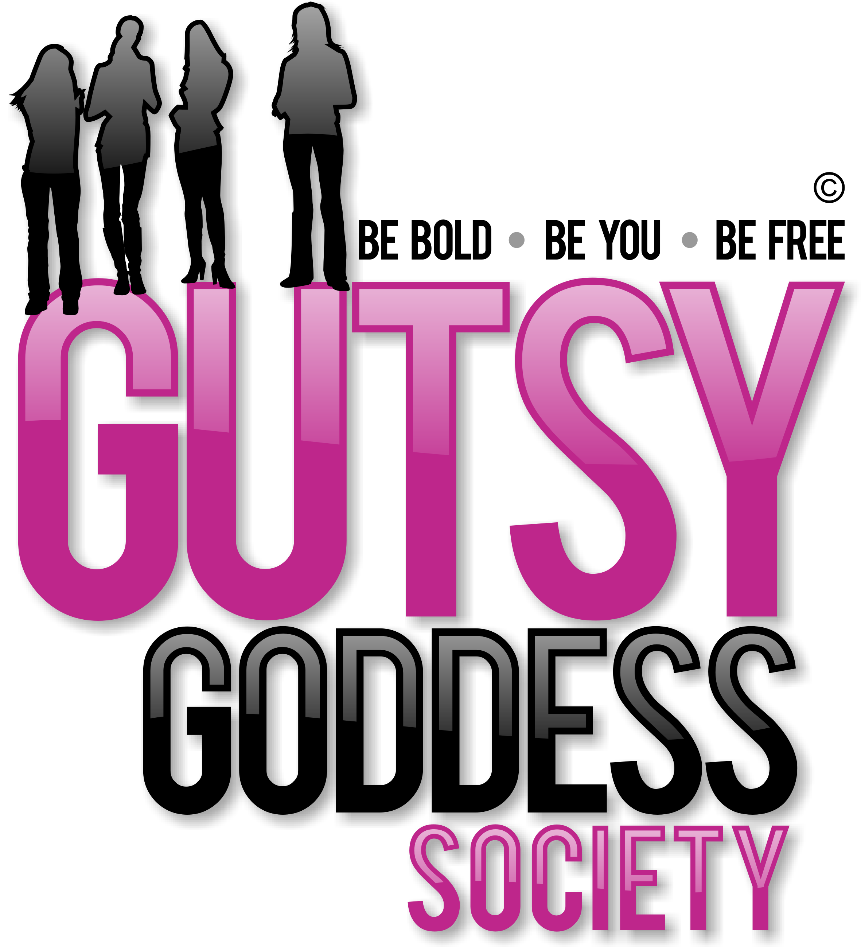

Month 9, Week #2
Go Outside
Wow. Welcome to Month 9 (our last!) of our Gutsy Goddess Society training program - Enjoying the Ride (Having More Fun!).
This month we're going to bring all the puzzle pieces together and conclude our program with a BANG! This is our 9th and final month together. What an adventure. This call is all about ensuring you are ENJOYING yourself and all the yumminess that life has to offer. If not, what's the point? Too many women fall short here. Let's pave the way for a female revolution where fun is the focus.
We covered this in depth on our monthly training call. It was profound. If you missed it, check it out here: http://jennyfenig.com/ggs-success-library-woo-hoo/
Okay, onto the weekly assignment ...
******************
INSPIRATION IN ACTION ASSIGNMENT
For all of us Northern Hemisphere goddesses, we are saying hello to SUMMER. That means it feels really good to be outside, right?! :) So your focus right now is to get OUTSIDE and PLAY. Have fun. Enjoy the feel of the air on your skin.
If you're one of those women who likes to strategize on everything, you might find it hard to simply PLAY. If that's you, you might need a more planned approach. Look for courses that offer structured play ... like an outdoor ropes course ... or paintball ... or mini golf ... or a fun tennis match.
Or plan an awesome outing with pals to a baseball game or a kids' soccer match.
Or ... find a workshop or retreat to attend where being in nature is part of the experience. The Retreat for Goddesses is a PERFECT spot for you to enjoy yourself in a magical spot. Are you coming? I hope so!
******************
We've moved up all the chakras together. This is the pinnacle. Let's enjoy this ride to the fullest. You've earned it. You're a survivor and a thriver ...
xoxo
Jenny
P.S. Have fun!

