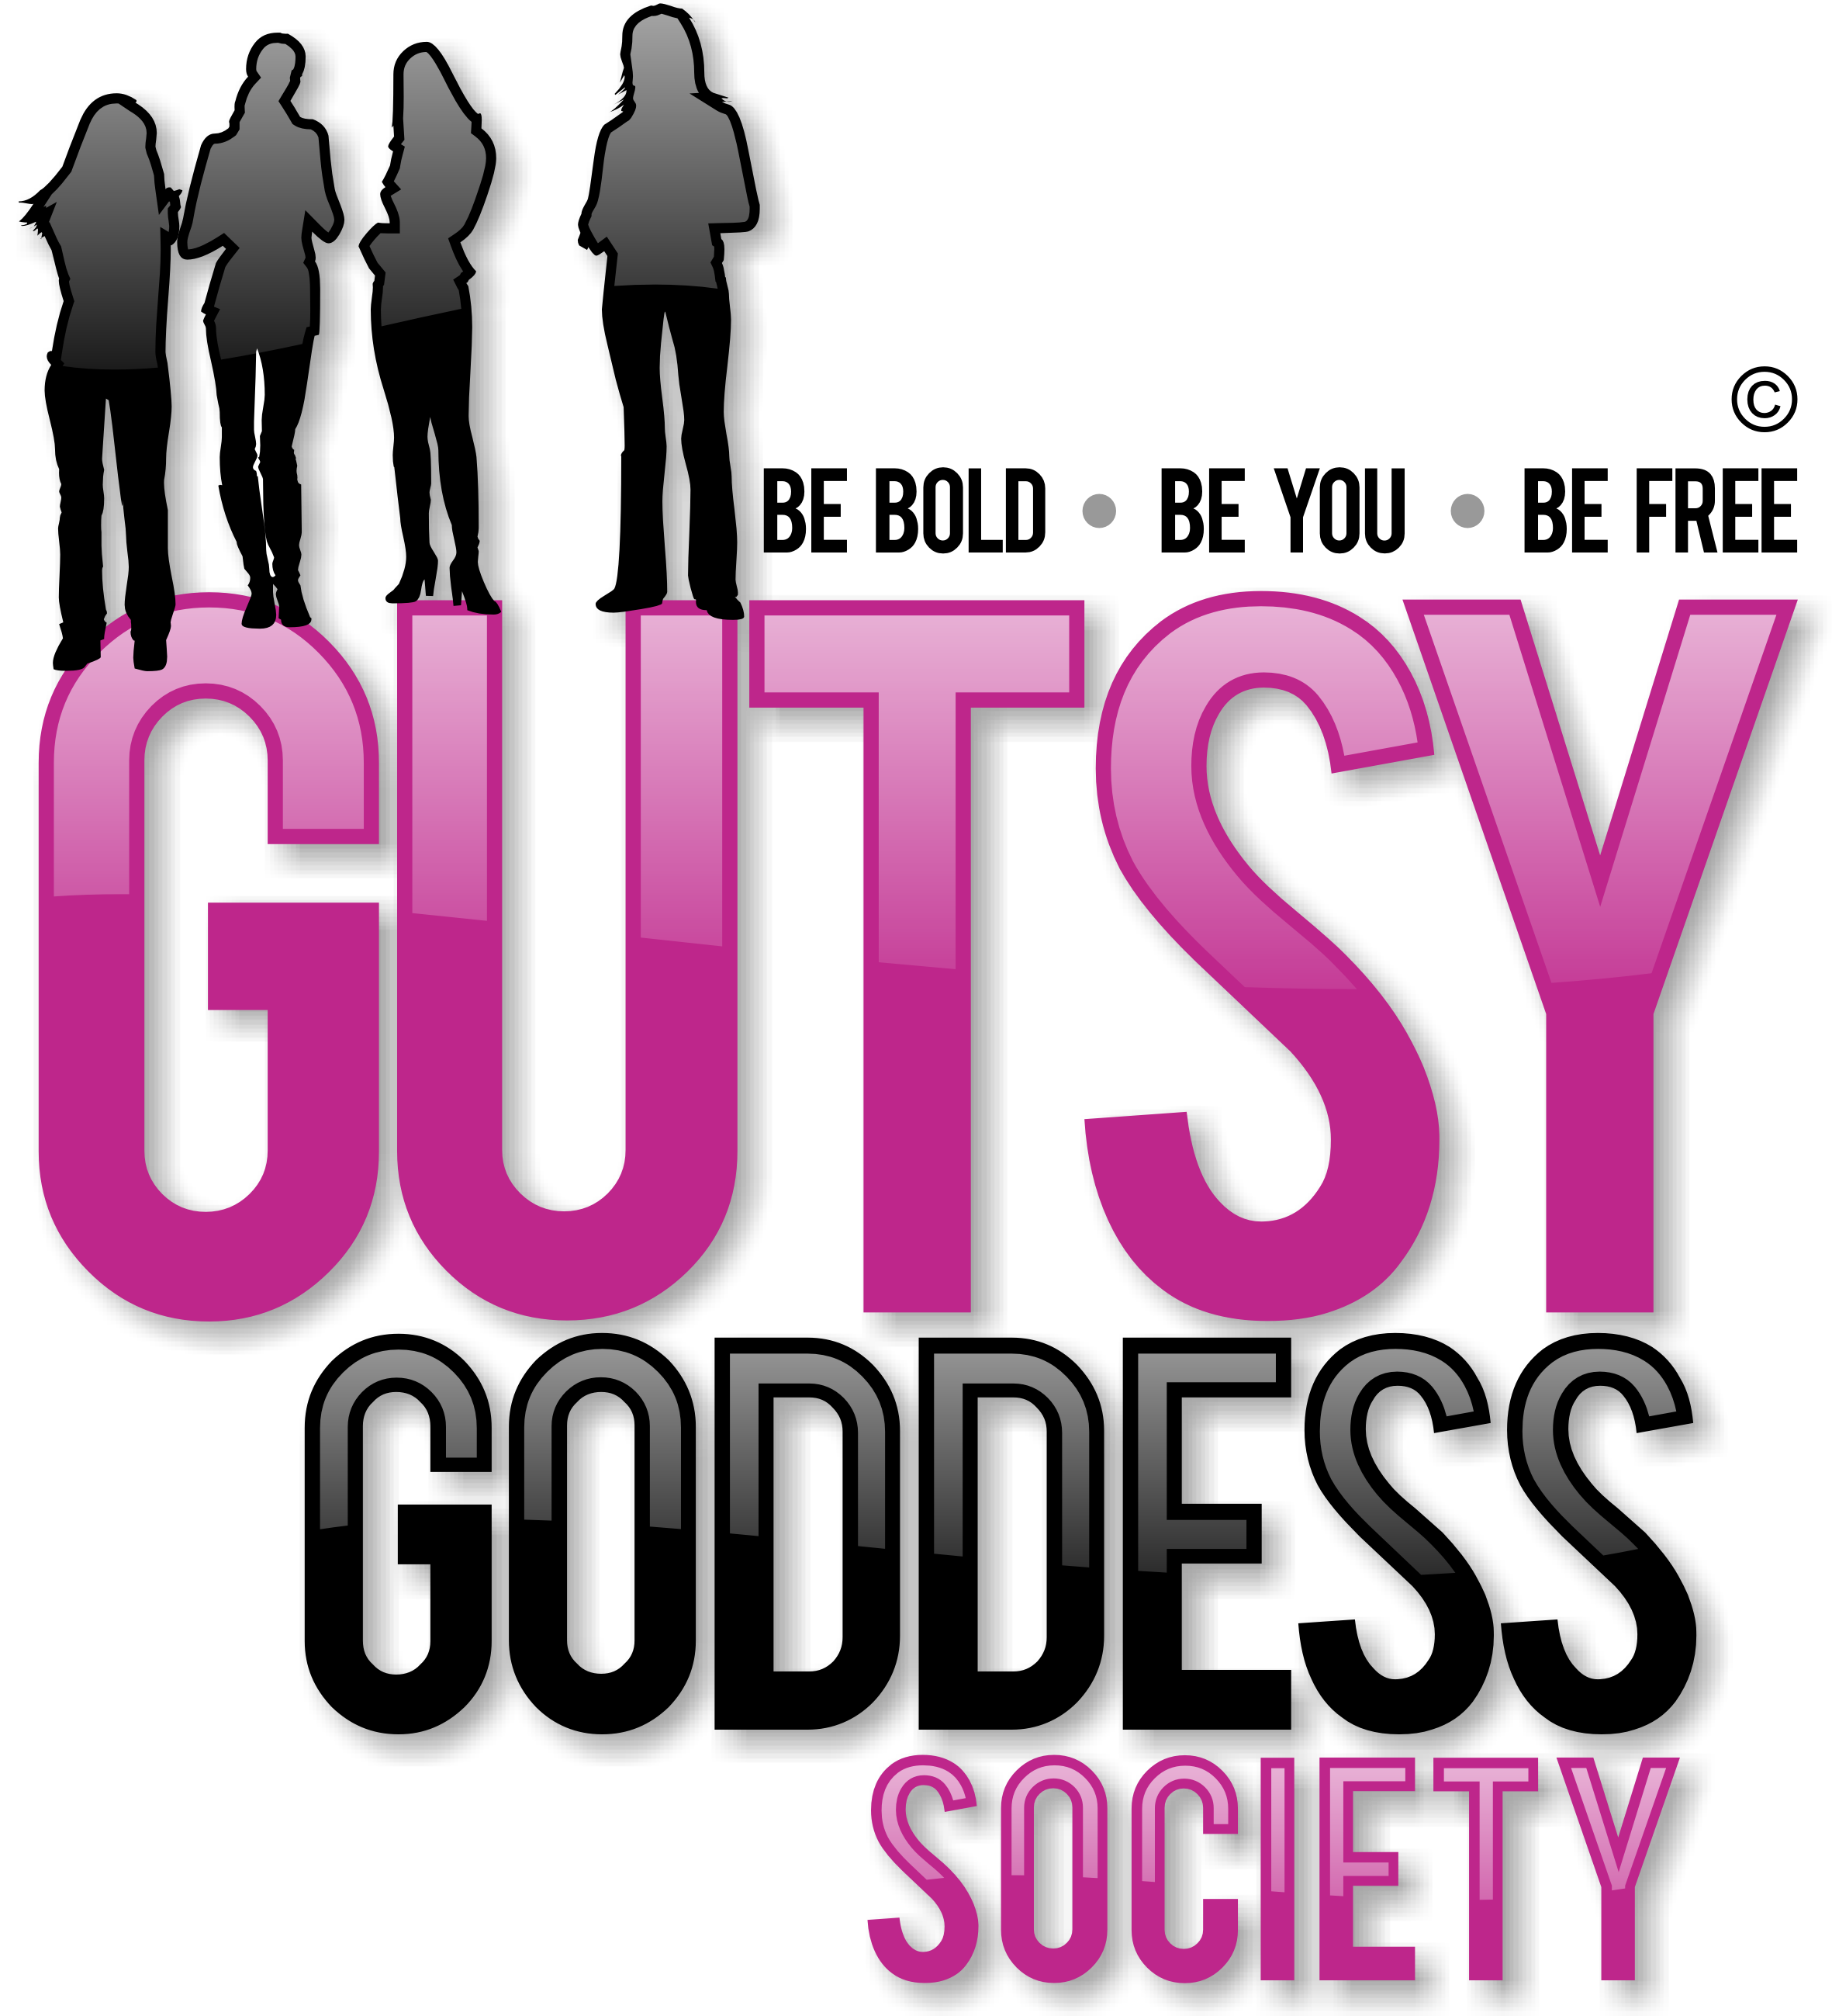

Month 9, Week #3
Enjoying the Ride (Having More Fun!).
Wow. Welcome to Month 9 (our last!) of our Gutsy Goddess Society training program - Enjoying the Ride (Having More Fun!).
This month we're going to bring all the puzzle pieces together and conclude our program with a BANG! This is our 9th and final month together. What an adventure. This call is all about ensuring you are ENJOYING yourself and all the yumminess that life has to offer. If not, what's the point? Too many women fall short here. Let's pave the way for a female revolution where fun is the focus.
We covered this in depth on our monthly training call. It was profound. If you missed it, check it out here: http://jennyfenig.com/ggs-success-library-woo-hoo/
Okay, onto the weekly assignment ...
******************
INSPIRATION IN ACTION ASSIGNMENT
If you're anything like me, are you finding you are LESS interested in noisy bars and clubs and you're MORE interested in having fun at home?
Yes?!
How about creating a playdate with your pals for some old-school fun: Game Night!
Bust out old faves like Trivial Pursuit, Monopoly, Scattergories, Twister or charades. Serve some yummy snacks, light some candles, put on some good tunes and have a BALL.
Play, play, play. Play helps you ENJOY THE RIDE, which is THE POINT.
******************
We've moved up all the chakras together. This is the pinnacle. Let's enjoy this ride to the fullest. You've earned it. You're a survivor and a thriver ...
xoxo
Jenny
P.S. Have you seen the NEWS? The Retreat for Goddesses is almost full. Check out the transformational experience here and join us if you feel called. http://retreatforgoddesses.com

